ENERGY RECOVERY OF INDUSTRIAL WASTE: ENVIRONMENTAL, ECONOMIC AND SOCIAL SUSTAINABILITY

[Sustainability](https://innergy-global.com/en/sustainability), [Eficiencia energética](https://innergy-global.com/en/eficiencia-energetica" \o "Eficiencia energética), [Biomass](https://innergy-global.com/en/biomass), [Residues](https://innergy-global.com/en/residues)

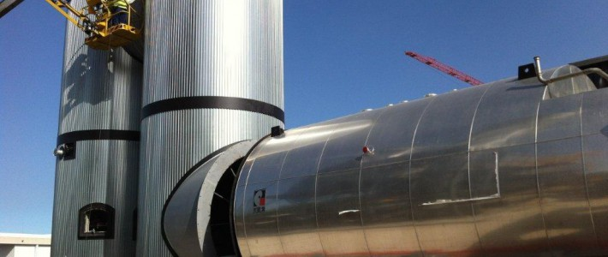

**INDUSTRIAL WASTE: A PROBLEM OR A SOLUTION?**

Our population’s health is affected by the continuous **generation of untreated waste**; moreover, this problem is accentuated by environmental, resource and energy problems.

The need to **efficiently manage waste is increasingly urgent**, both for citizens and industry. Furthermore, it is necessary to control the generation of waste that occurs inevitably during our time spent on this planet.

By introducing different processes in the **treatment of waste**, it is possible to turn it into a resource, having a great use potential for society. Through the installation of**waste treatment and** **recovery techniques**, in the case of industrial remnants, it is feasible to convert that waste into energy resources, saving management costs and reducing emissions.

THERE ARE CURRENTLY 2 TYPES OF WASTE RECOVERY PROCESSES:

* **WASTE ENERGY RECOVERY**.

This consists of obtaining energy through the incineration of waste, eliminating it and generating energy, which entails both a savings in management and lower energy costs.

* **MATERIAL RECOVERY.**

This includes the techniques used to create new materials from waste, avoiding the use of new raw materials. By taking advantage of organic matter: packaging, paper or cardboard and glass, you can obtain new materials with which to make products with less ecological footprint.

**FROM THE PROBLEM TO THE BENEFITS GENERATED BY THE RECOVERY OF INDUSTRIAL WASTE.**

**WHAT IS INDUSTRIAL WASTE RECOVERY?**

Given the need and obligation to manage the industrial waste produced, there are different problems that companies must face, such as energy dependence, the economic cost derived from contracting third parties, pollution rates, etc. For all these issues, the **recovery of industrial waste** is essential, since it is the process by which waste is used to obtain energy yields.

**CAN MY BUSINESS RECOVER ENERGY FROM THE WASTE IT PRODUCES?**

It is possible to obtain a **tailor-made solution which can contribute to making your company more economically and energetically efficient** by requesting advice from companies specialized in energy generation and waste treatment. The initial cost can become a resource and as well as a way to save money and promote the growth of the business models of industrial companies.

Residues such as sludge, glycerine, vinasse, CDS/CSR, MSW, used oil, etc. are continuously treated and valorized, transforming the same into energy after incorporation into waste treatment systems in different industries, such as chemical and pharmaceutical, paper and cardboard, animal by-products, water treatment or waste managers.

**THE WASTE RECOVERY PROCESS IN THREE PHASES:**

The following three phases constitute the **industrial waste recovery process** for INNERGY, a pioneer in the development of combustion systems for the recovery of industrial waste.

1. **Preliminary Analysis:**

For a detailed evaluation of the situation, INNERGY compiles the necessary data through a first contact. After this process, INNERGY offers different possibilities and opportunities depending on the feasibility.

1. **Detailed Study:**

Based on the data obtained and the particular needs of the client, the preliminary project is launched. INNERGY can outline all the details by means of **valorization tests** of the waste in question, thanks to a pilot plant located in its facilities, thereby minimizing the risks.

1. **Project Execution:**

In the last phase, INNERGY develops detailed engineering, design and manufacturing of equipment, assembly and commissioning. An integral service, from engineering and design to manufacturing. In this way the client can focus solely on their main activity without additional worries.

INNERGY offers an integral service for the valorization solution, and it is a partner that develops engineering and manufacturing, guarantees the service, and ensures communication and performance, that is to say, it provides a close, continuous and direct support.

**ADVANTAGES OF THE INTEGRATION OF WASTE RECOVERY PROCESSES**

The incorporation of industrial boilers, that is, equipment for the recovery of industrial waste, is an investment with multiple advantages, attributes that will be converted into savings, better management and self-sufficiency.

* Self-sufficient energy generation
* Energy autonomy
* Independence from third parties regarding waste management and treatment
* Savings in costs and expenditures
* Fuel price control due to the independent performance with respect to the markets

**MAKE IMPROVEMENTS IN THE PRESENT TO OPERATE BETTER IN THE FUTURE**

The problem of waste management is inevitable and must be faced by society, cities and communities. Moreover, it is essential to solve this problem by always applying the least polluting and ecological treatment, and by keeping in mind that simply doing nothing should never be a solution.